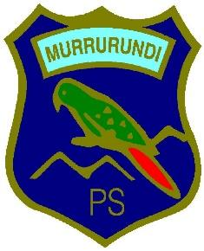
Murrurundi Public School
“Pride in our Heritage, Confidence in our Future”
135 Mayne Street, Murrurundi, NSW, 2338
Phone: 02 6546 6057 Fax: 6546 6596
Email: Murrurundi-p.school@det.nsw.edu.au

WHAT TO BRING

LUGGAGE
- One bag is ideal as students will be carrying their own bag. Make sure it is not too big!
- It is a good idea for students to pack their own bags, so they can pack their bags on return
- Luggage should be clearly labelled

DAY BAG
- Clearly labelled water bottle
- Broad brimmed hat – no caps
- Sunscreen
- Tissues
- Wet weather gear
- Wallet
- Food for day 1 – fruit break, lunch, and snacks (no lollies, chewing gum or soft drink)

CLOTHING
- Warm shirts and a jacket
- T-shirts – must cover shoulders and stomach
- Jeans or tracksuit pants
- Shorts or skirts
- Underwear
- Warm socks
- Enclosed shoes – no thongs or sandals
- Warm pyjamas
- Waterproof jacket
- One set of summer school uniform + jumper

TOILETRIES
- Toothbrush and toothpaste
- Soap
- Shampoo and conditioner
- Hairbrush
- Roll on deodorant – no aerosols

OTHER
- Garbage bag for dirty clothes
- Torch (optional)
- A small toy

MEDICATION
- Please ensure teachers are aware of any required medication – a form must be filled out prior to leaving
- All medication must be in original packaging, clearly marked with he student’s name, required dosage and dosage interval
- Place medication in a zip lock bag and hand in to the teachers. Students must not carry their own medication.

SPENDING MONEY
- We are placing a limit of $50 for spending. This is to be placed in an envelope and handed into the teachers prior to departure.

DEVICES
- Students are NOT to bring any devices with them. This includes, but is not limited to, mobile phones, ipads, electronic games.
- Staff will be available if you need to contact your child

NOTE:
- Bath towels, sheets and bedding will be supplied
- Students can bring a small pillow for the bus if they wish

